OOJ LAB RECORD 9-10

BY S.R.POOJA 1BM19CS135

9.Write a program which creates two threads, one thread displaying “Bms college of engineering” once every ten seconds and another displaying “CSE” once every two seconds.

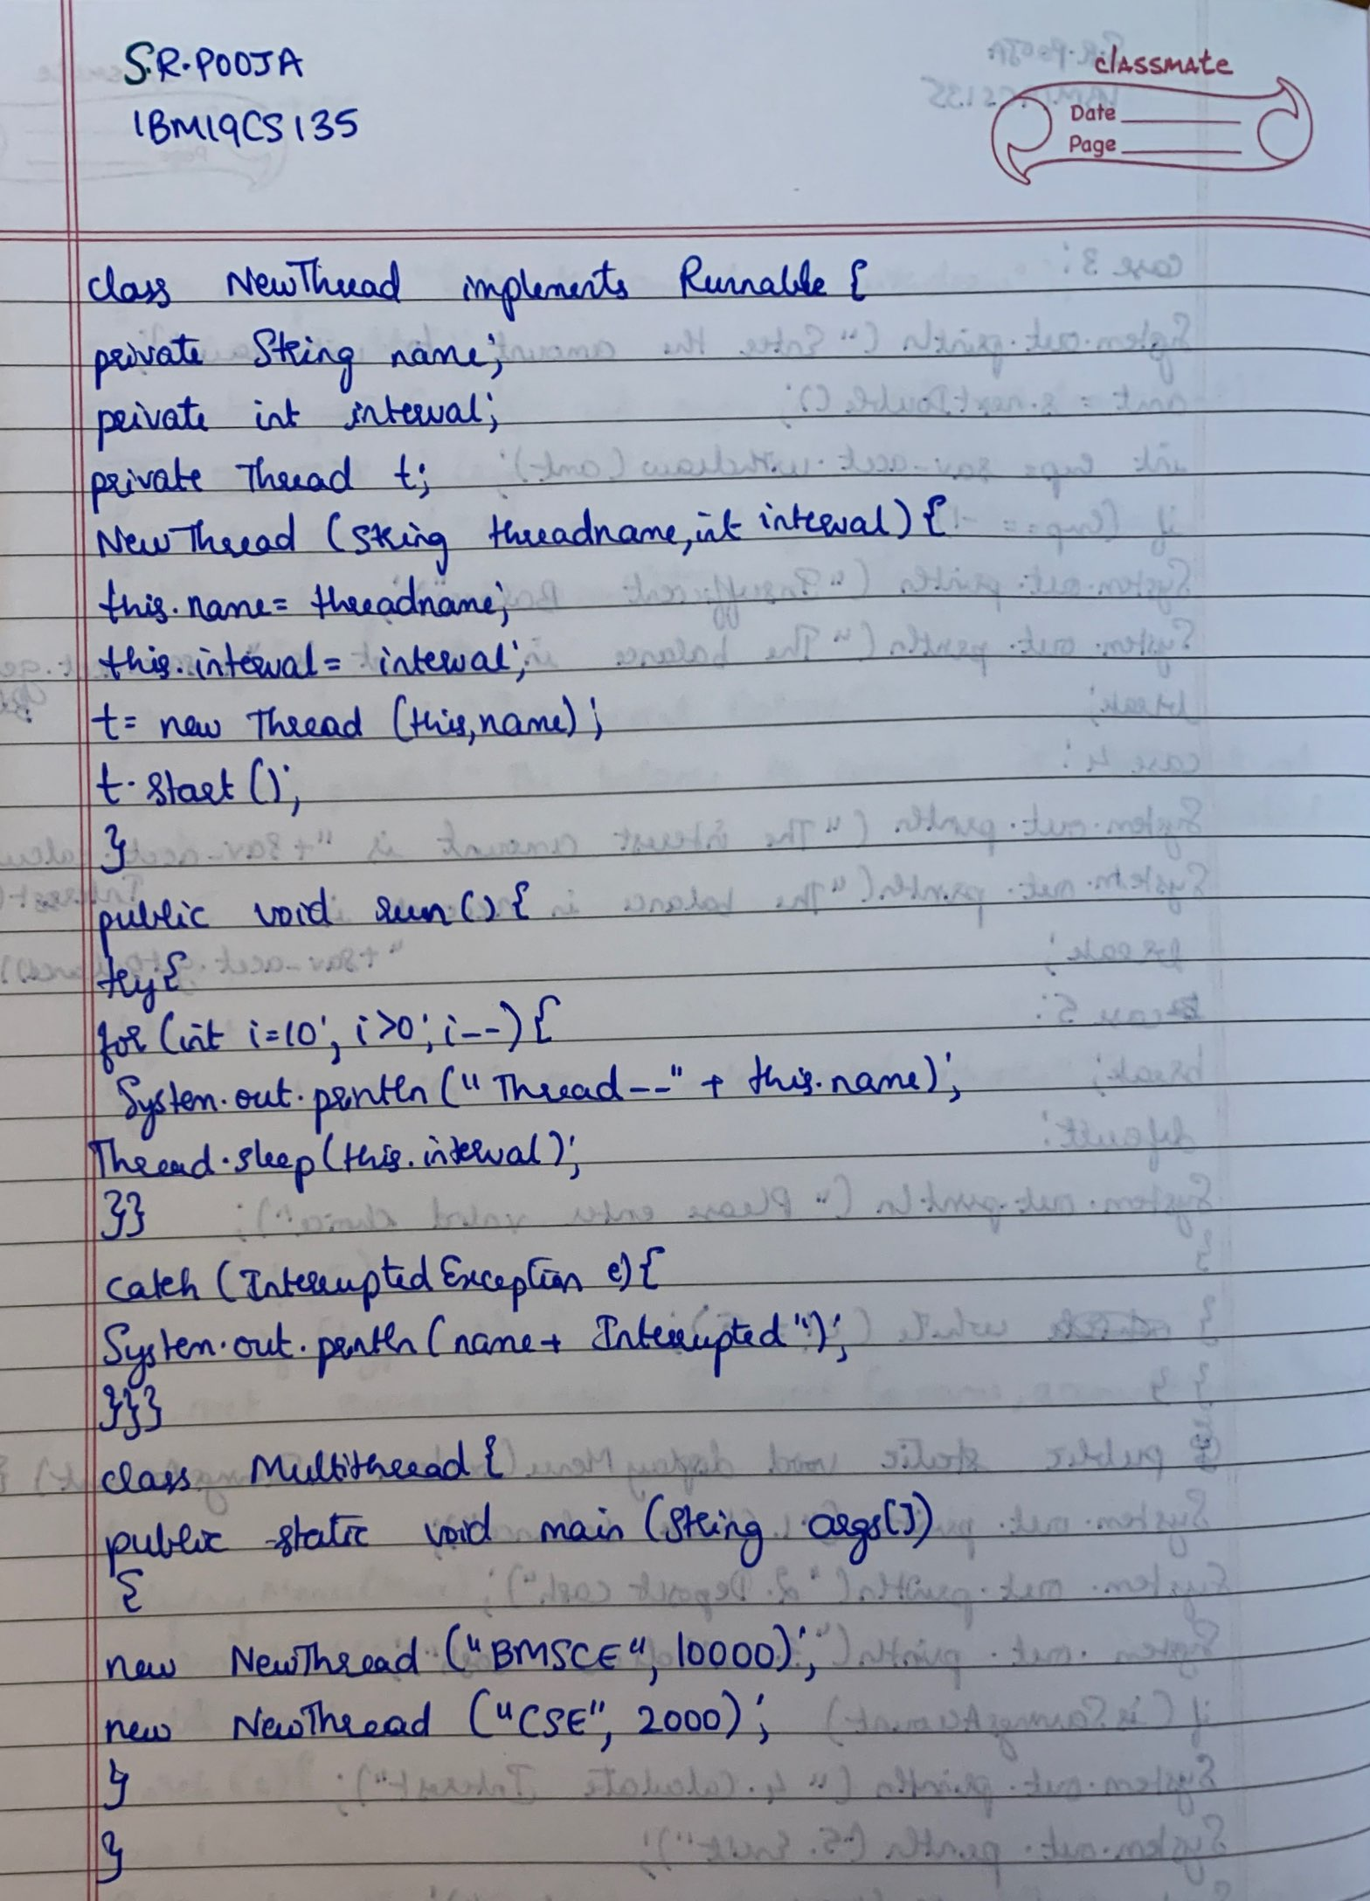

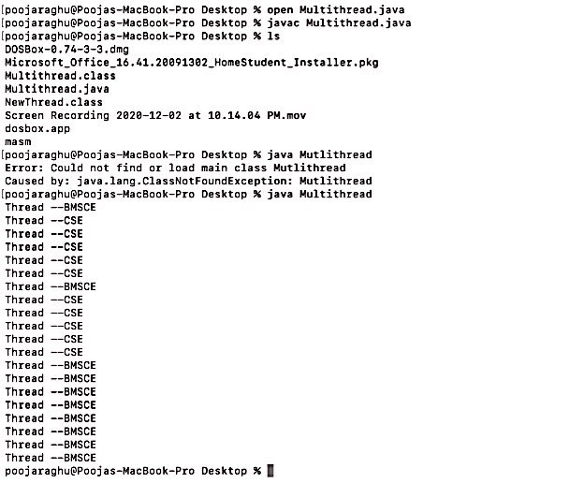

10. Write a program that creates a user interface to perform integer divisions. The user enters two numbers in the text fields, Num1 and Num2. The division of Num1 and Num2 is displayed in the Result field when the Divide button is clicked. If Num1 or Num2 were not an integer, the program would throw a Number Format Exception. If Num2 were Zero, the program would throw an Arithmetic Exception Display the exception in a message dialog box.

